EMPLOYEE PAYROLL SYSTEM

MINOR PROJECT REPORT

SUBMITTED IN PARTIAL FULFILMENT OF THE REQUIREMENTS FOR THE AWARD OF THE DEGREE OF

BACHELOR IN COMPUTER APPLICATION
(BCA)


Submitted By: Submitted To:
DEEPANSH CHAND Mr. Keshav Bhatt
Enrollement No.- (Head of Department)
(BCA 1st Semester) (I.T. Department)

Department of Information Technology
KITM Group of Institutions, Khatima
262308

ABSTRACT

The Employee Payroll System is a computerized application designed to simplify and automate the process of managing employee salary information in an organization. The main purpose of this project is to maintain employee records such as employee ID, name, age, department, and salary details in a systematic manner.

The system calculates the employee’s gross salary by considering basic pay along with various allowances such as House Rent Allowance (HRA) and Dearness Allowance (DA). It also calculates deductions like tax to generate the final net salary.

The Employee Payroll System provides basic functionalities such as adding new employee details, updating existing records, searching employee information, and generating salary reports. This reduces paperwork and helps management access payroll information quickly and easily. The system is designed using fundamental programming concepts, making it simple to understand and operate even for users with basic computer knowledge.

This project helps students understand real-world applications of programming by implementing concepts like data structures, functions, file handling, and control statements. Overall, the Employee Payroll System improves efficiency, reduces human effort, and provides a reliable solution for payroll management, making it suitable for academic learning as well as small organizational use.

MINOR PROJECT APPROVAL

This minor project entitled “Employee Payroll System” by Name is approved for the degree of Bachelor in Computer Application.

EXAMINERS:-

1.................................................
(Internal Examiner Name and Sign)

2.................................................
(External Examiner Name and Sign)

DATE :- ........................

ACKNOWLEDGEMENT

I am highly grateful to the Mr. Keshav Bhatt, Head of Department, KITM College, Khatima, for providing this opportunity to carry out the minor project work.

The constant guidance and encouragement received from Mr. Keshav Bhatt, Head of Department of IT department, KITM Khatima has been of great help in carrying out the project work and is acknowledged with reverential thanks.

I would like to express a deep sense of gratitude and thanks profusely to Mr. Keshav Bhatt, without his wise counsel and able guidance, it would have been impossible to complete the project in this manner.

I express gratitude to other faculty members of Information Technology Department of KITM for their intellectual support throughout the course of this work.

Finally, I am indebted to all whosever have contributed in this report work.

Deepansh Chand
Gopal Vishwas
Deepak Kalouni
(BCA 1st Semester)

BONAFIDE CERTIFICATE

This is to certify that the minor project entitled “EMPLOYEE PAYROLL SYSTEM” submitted by DEEPANSHC CHAND as in partial fulfilment for the requirements for the award of the degree of Bachelor in Computer Application is an authentic work carried out by them under my supervision and guidance.

To the best of my knowledge, the matter embodied in the project report has not been submitted to any other University/Institute for the award of any Degree or Diploma.

Signature of Head of the Department
Mr. Keshav Bhatt
Department of INFORMATION TECHNOLOGY,
KITM Group of Institutions
Udham Singh Nagar, Khatima-262308, Uttarakhand.

Submitted for the partial fulfilment for the award of the degree of Bachelor in Computer Application in INFORMATION TECHNOLOGY from KITM Group of Institutions Udham Singh Nagar, Khatima-262308, Uttarakhand. u/s 3 of UGC Act, 1956.

PREFACE

This project titled “Employee Payroll System” has been developed as part of the BCA first semester curriculum to gain practical knowledge of programming concepts and their real-life applications. The payroll system plays an important role in every organization as it is responsible for managing employee salary details accurately and efficiently. Through this project, an effort has been made to understand how computerized systems can replace manual methods and improve overall productivity.

The main motivation behind choosing this project is to learn how employee information and salary calculations can be managed using a structured and systematic approach. In traditional payroll systems, manual calculations often lead to errors and require a lot of time and effort. This project helps in understanding how automation can reduce such problems by performing calculations accurately and maintaining records in an organized manner.

This project also provides an opportunity to apply the fundamental concepts of programming learned during the course, such as variables, data types, control structures, functions, arrays, and file handling. By working on this project, students gain hands-on experience in developing a small-scale application, which enhances problem-solving skills and logical thinking.

Finally, this project has helped in developing confidence and technical skills required for future academic and professional growth. It serves as a foundation for understanding more advanced concepts in software development and system design. The Employee Payroll System project not only fulfills academic requirements but also prepares students to develop practical solutions for real-world problems.

CONTENT

Sr. No | PARTICULARS | PAGE NO.
1 | Introduction | 1
2 | Objectives of Project | 2
3 | Project Category | 3
4 | Requirement Analysis | 4
5 | System Specification | 5
6 | Problem Formulation | 6
7 | Identification of need | 7
8 | Proposed System | 8
9 | Feasibility Study | 9
10 | System requirment Specification (SRS) | 10
11 | Expected Hurdels | 11
12 | SDLC Model to be used | 12, 13
13 | Introduction to Language, Tools and Technologies | 14
14 | System Design | 15, 16
15 | Data Flow Diagram | 17
16 | Design Approach | 18
17 | Testing | 19, 20
18 | OUTPUT | 21, 22, 23
19 | Quality Assurance | 24
20 | Maintenance | 25
21 | Future Scope and Conclusion | 26, 27
22 | Bibliography | 28

INTRODUCTION

In today’s fast-growing digital world, organizations are increasingly using computerized systems to manage their daily operations efficiently. One of the most important administrative tasks in any organization is payroll management. Payroll involves calculating employee salaries, maintaining employee records, and generating salary reports. The Employee Payroll System project is designed to automate this process and reduce the dependency on traditional manual methods.

Manual payroll systems are often time-consuming and prone to human errors such as incorrect calculations, missing records, and data inconsistency. Maintaining employee details on paper also makes it difficult to update, search, or retrieve information quickly. This project aims to overcome these limitations by providing a computerized solution that can accurately manage employee data and salary details in a structured manner.

The Employee Payroll System allows the user to perform essential payroll operations such as adding new employees, updating employee information, deleting employee records, viewing employee details, and generating payroll slips. The system automatically calculates salary components like Basic Salary, House Rent Allowance (HRA), Dearness Allowance (DA), gross salary, tax, and net salary. This ensures accuracy, consistency, and transparency in salary processing.

This project has been developed using basic programming concepts, making it easy to understand and use. It provides hands-on experience in implementing concepts such as arrays, functions, conditional statements, loops, and file handling. The Employee Payroll System not only fulfils academic requirements but also helps students understand how real-world payroll systems work. It serves as a strong foundation for learning advanced software development concepts in future semesters.

OBJECTIVE OF THE PROJECT

The main objective of the Employee Payroll System project is to design and develop a computerized system that simplifies the process of managing employee payroll in an organization. The project aims to automate salary calculation and employee record management, thereby reducing manual effort and improving efficiency. By using this system, organizations can process payroll operations accurately and in less time.

Another important objective of this project is to maintain employee information in an organized and structured manner. The system stores essential details such as employee ID, name, age, department, and salary information. This helps in quick retrieval, updating, and deletion of employee records whenever required. Proper record management ensures data consistency and reduces the chances of duplication or data loss.

The project also aims to ensure accurate salary computation by automatically calculating salary components like Basic Salary, House Rent Allowance (HRA), Dearness Allowance (DA), gross salary, tax, and net salary. Automated calculations minimize human errors and provide reliable payroll results. Generating payroll slips and reports helps management understand salary distribution clearly.

In addition to functional objectives, this project aims to enhance the practical programming skills of students. It helps in understanding the real-world application of concepts such as arrays, functions, conditional statements, loops, and file handling. The project also improves problem-solving ability, logical thinking, and confidence in developing small-scale applications. Overall, the Employee Payroll System project serves both academic and practical purposes by providing a simple, efficient, and reliable payroll management solution.

PROJECT CATEGORY

The Employee Payroll System is categorized based on its application type, domain, technology, data management approach, and user access. These categories help in clearly understanding the nature and scope of the project.

•eApplicationeCategory:
This project is a desktop-based application that runs on a local computer system. It operates through a command-line interface and does not require an internet connection, making it suitable for offline payroll processing.

•eDomaineCategory:
The project falls under the Business Application and Management Information System (MIS) domain. It focuses on managing employee salary records, payroll calculations, and administrative tasks efficiently within an organization.

•eTechnologyeCategory:
The Employee Payroll System is developed using the C programming language. It makes use of fundamental programming concepts such as arrays, functions, loops, conditional statements, and file handling, which makes it appropriate for beginner-level academic projects.

•eDataeManagementeCategory:
This project is classified as a file-based system. Employee and payroll data are stored in a text file, ensuring data persistence and easy retrieval even after the program is closed.

•eUsereAccesseCategory:
The system is designed as a single-user (administrator) application. The administrator has full control over adding, updating, deleting employee records and generating payroll reports, ensuring secure and controlled data access.

REQUIREMENT ANALYSIS

For the Employee Payroll System, requirement analysis focuses on identifying the functional needs, technical requirements, and limitations of the system. This process ensures that the developed system meets user expectations and project objectives.

•eFunctionaleRequirements:
The system must allow the user to add new employee records with details such as employee ID, name, age, department, and basic salary. It should provide options to view employee details, update existing records, and delete employee information when required. The system must automatically calculate salary components including HRA, DA, gross salary, tax, and net salary. It should also generate payroll reports and save employee data in a file for future use.

•eNon-FunctionaleRequirements:
The system should be user-friendly and easy to operate through a menu-driven interface. It must ensure accuracy in salary calculations and consistency in employee data. The system should be efficient in terms of response time and should handle multiple employee records without errors. Data stored in files should remain secure and should not be lost during program execution.

•eHardwareeRequirements:
A basic computer system with a minimum of 2 GB RAM, a standard keyboard, and a display unit is sufficient to run the application.

•eSoftwareeRequirements:
The system requires a C compiler such as GCC or Turbo C, along with any standard operating system like Windows or Linux.

•eConstraints:
It is a single-user application and does not include advanced security or database features.

SYSTEM SPECIFICATION

System specification defines the hardware and software requirements needed to develop and run the Employee Payroll System efficiently. This project is designed as a lightweight, file-based application and does not require high-end system resources.

Hardware Requirements
- Minimum 2 GB RAM
- Standard keyboard and monitor
- Basic processor capable of running C programs
Software Requirements
- C Programming Language
- C Compiler: GCC / Turbo C / Dev-C++
- Operating System: Windows / Linux / macOS
Development Environment
- Text Editor or IDE such as Dev-C++, Code::Blocks, or VS Code
Storage Requirements
- Text file storage (employees.txt)
- Minimal disk space required

PROBLEM FORMULATION

In many small organizations and offices, employee salary management is still performed manually. Payroll calculations are done using registers or spreadsheets, which is time-consuming and prone to human error. Managing employee details, attendance records, allowances, and deductions manually becomes difficult when the number of employees increases. Even a small mistake in calculation can lead to incorrect salary payment and dissatisfaction among employees.

Manual payroll systems also create problems in maintaining proper records. Searching for employee information, updating salary details, and preparing monthly salary reports require a lot of effort. In addition, preparing payslips for every employee every month is repetitive and slow. There is also a risk of data loss because paper records can be misplaced or damaged.

Another issue is accuracy and transparency. Employees cannot easily verify how their salary is calculated, including deductions such as tax and provident fund. This may create confusion and disputes between employees and management.

To overcome these problems, a computerized Employee Payroll System is required. The system will store employee details in a database and automatically calculate salary based on predefined rules. It will add allowances, deduct taxes, and generate payslips quickly and accurately. The system will also maintain records safely and allow easy updating and retrieval of information.

Therefore, the main aim of this project is to develop a simple, reliable, and efficient payroll management system that reduces manual work, improves accuracy, saves time, and provides better record management.

IDENTIFICATION OF NEED

In many organizations, salary management is a very important task. Employees expect their salary to be calculated accurately and paid on time. However, in small offices and institutions, payroll work is often done manually using registers or basic spreadsheets. This manual process requires a lot of time and effort and increases the chances of mistakes.

Manual payroll management creates difficulty in maintaining employee records such as employee ID, department, designation, attendance, and salary details. When the number of employees increases, handling all information becomes complicated. Calculating salary by hand, including allowances and deductions like tax and provident fund, is not only slow but also error-prone. Even a small calculation mistake can result in wrong salary payment and dissatisfaction among employees.

There is also a need for proper record keeping and quick report generation. Organizations often need monthly salary reports and individual payslips. Preparing these documents manually takes a long time and may cause delays. In addition, paper records are not secure and can be lost or damaged.

Therefore, a computerized Employee Payroll System is necessary. The system will store employee data safely, automatically calculate salary, and generate payslips instantly. It will reduce paperwork, save time, and improve accuracy. It will also make it easier to update records and retrieve information whenever required.

Hence, the need for this project arises from the requirement of a fast, accurate, reliable, and secure method for managing employee payroll operations.

PROPOSED SYSTEM

The proposed system is a computerized Employee Payroll System developed to automate the process of employee salary management. The system replaces the manual method of maintaining salary records and performing calculations. It is designed to provide an easy, fast, and accurate way to manage employee information and payroll activities.

In this system, the administrator can add, update, and delete employee details such as employee ID, name, department, designation, and basic salary. The system will store all records in a database, which makes data management secure and organized. It also reduces paperwork and minimizes the chances of losing important records.

The proposed system automatically calculates the salary of employees. It adds allowances such as HRA and bonus and deducts amounts like tax and provident fund. After calculation, the system generates the gross salary and net salary. The payslip is then prepared and can be viewed or printed easily. This reduces calculation errors and saves time.

The system also allows searching employee records and generating monthly reports. The administrator can quickly retrieve employee information whenever required. Proper validation is provided to avoid wrong data entry and improve accuracy.

The proposed system is user-friendly so that even a person with basic computer knowledge can operate it easily. It improves efficiency, reduces manual work, and ensures correct salary payment. Overall, the system provides a reliable and secure solution for managing payroll operations in an organization.

FEASIBILITY STUDY

A feasibility study is conducted to evaluate whether a proposed system is practical and suitable for development. It helps in understanding the technical, economic, operational, and time-related aspects of the project. For the Employee Payroll System, the feasibility study confirms that the project can be successfully developed using available resources and within academic constraints.

1. Technical Feasibility
Technical feasibility examines whether the required technology and technical skills are available to develop the system. The Employee Payroll System is developed using the C programming language, which is part of the BCA first semester syllabus.

2. Economic Feasibility
Economic feasibility analyzes the cost involved in developing and using the system. This project does not require any additional financial investment as it uses free or already available resources.

3. Time Feasibility
Time feasibility determines whether the project can be completed within the given time frame. As the project scope is limited and uses simple logic, it can be completed within the academic schedule. Therefore, the Employee Payroll System is time feasible.

Conclusion of Feasibility Study
Based on the above analysis, the Employee Payroll System is technically, economically, operationally, and time feasible. It is a practical and suitable project for academic purposes.

SOFTWARE REQUIREMENT SPECIFICATION (SRS)

The Software Requirement Specification (SRS) describes the functional and non-functional requirements of the Employee Payroll System. The main purpose of this system is to automate the process of employee salary calculation and record management. It helps the organization reduce manual work, minimize calculation errors, and maintain employee payment records efficiently.

Functional Requirements
The system should allow the administrator to add, update, and delete employee records. Each employee record will include employee ID, name, department, designation, and basic salary. The system should accept attendance or working days and calculate salary automatically.
The system must calculate gross salary by adding allowances such as house rent allowance and bonus. It should also calculate deductions like tax and provident fund. After calculations, the system should generate the net salary and display a payslip. The administrator should also be able to save and view payroll records whenever required.

Non-Functional Requirements
The system should be simple and user-friendly so that the administrator can easily operate it. It must provide accurate salary calculations and quick response time. Data security is important; therefore, only authorized users should be able to access employee data. The system should store records safely in a database and prevent data loss.
The software should run on a computer system with basic configuration and should not require high hardware specifications. It must be reliable and capable of handling multiple employee records without errors.
Thus, the Employee Payroll System will provide an efficient, secure, and accurate way to manage employee salary information and payroll processing.

EXPECTED HURDLES

While developing and using the Employee Payroll System, some difficulties may occur which can affect the working of the system.

The first major problem is wrong data entry. The system fully depends on the information entered by the administrator. If incorrect employee details, attendance, or salary amount is entered, the salary calculation will also become incorrect and may create problems for employees.

Another hurdle is salary calculation complexity. Salary includes basic pay, allowances, bonus, tax, and provident fund deductions. If formulas are not properly applied, the generated net salary may be wrong.

The system may also face technical errors such as program bugs, database connection failure, or software crash. These errors can stop the system from saving records or generating payslips properly.

Data security is also important because the system stores confidential employee information. Unauthorized access can lead to data loss or misuse.

Finally, maintenance and user knowledge can be a challenge. Changes in tax rules or salary policies require system updates, and untrained users may not operate the system correctly.

Therefore, proper testing, security, and regular maintenance are necessary for smooth functioning of the Employee Payroll System.

SDLC MODEL TO BE USED

The Software Development Life Cycle (SDLC) model used in the Employee Payroll System project is the Prototyping Model. In this model, first a basic working version (prototype) of the software is created. This prototype shows how the system will look and work. After seeing the prototype, the user gives feedback and improvements are made. The final system is developed after modifying the prototype multiple times.

This model is suitable for the Employee Payroll System because at the beginning the exact requirements of the user were not fully clear. While developing the project, many changes were required such as adding new fields, modifying salary calculation, and improving the interface. Therefore, a prototype was first prepared and then gradually improved.

1. Requirement Gathering
In the first stage, basic requirements were collected. The system needed to store employee details such as employee ID, name, department, designation and salary. It also needed to calculate salary, apply allowances and deductions, and generate a payslip. However, some details like calculation method and format of payslip were not clear at the beginning.

2. Quick Design
A simple design of the system was prepared. Basic forms were created such as employee entry form and salary calculation form. At this stage, the aim was not perfection but to create a basic structure so the user could understand how the system would work.

3. Build Prototype
A working prototype of the Employee Payroll System was developed. The prototype allowed entering employee details and calculating salary. This helped to demonstrate the working of the system. The user could interact with the software and check its functionality.

4. User Evaluation
After using the prototype, feedback was collected. Some improvements were suggested such as adding deduction options (tax, PF), improving the payslip format, and making the interface easier to use. Errors and missing features were identified at this stage.

5. Refinement
Based on feedback, the system was modified and improved. Additional features like gross salary calculation, net salary calculation and report generation were added. The interface was improved and calculations were corrected.

6. Final Implementation and Maintenance
After multiple improvements, the final system was developed and tested. The software was ready for use. Even after completion, small corrections and updates could be made when needed.

Thus, the Prototyping Model is suitable for the Employee Payroll System because the system was developed step by step with continuous improvements. It helped in understanding requirements clearly and producing a user-friendly payroll management system.

INTRODUCTION TO TOOLS, LANGUAGES, AND TECHNOLOGIES

Programming Language
- C Programming Language is used to develop the Employee Payroll System.
- C provides fast execution, simplicity, and strong control over system resources.
- It supports structured programming, making the program easy to understand and maintain.

Development Tools
- C Compiler (GCC / Turbo C / Dev-C++) is used to compile and run the program.
- Text Editor or IDE such as Dev-C++, Code::Blocks, or Visual Studio Code is used for writing and editing the source code.

Technologies Used
- File Handling Technology is used to store and retrieve employee data from a text file.
- Menu-Driven Interface is used to interact with the user through options.
- Array-Based Data Storage is used to manage multiple employee records efficiently.

Operating System
- The project can run on Windows, Linux, or macOS.
- No internet connection is required for execution.

SYSTEM DESIGN

System design defines how the Employee Payroll System works internally and how different components of the system interact with each other. It provides a clear structure of data flow, modules, and processing logic used in the project.

System Architecture
- Menu-driven C-based desktop application
- Command-line interface for user interaction
- File-based data storage system

Input Design
- Employee ID
- Employee Name
- Employee Age
- Department
- Basic Salary
- Input provided through keyboard

Process Design
- Add, update, view, and delete employee records
- Automatic calculation of:
  - HRA (20% of Basic)
  - DA (10% of Basic)
  - Gross Salary
  - Tax (5% of Gross)
  - Net Salary
- Generate payroll reports

Output Design
- Display employee and payroll details on screen
- Save payroll data in employees.txt file

Data Storage Design
- Temporary storage using arrays
- Permanent storage using text file
- Data loaded at program start and saved on exit

Module Design
- addEmployee()
- viewEmployee()
- updateEmployee()
- deleteEmployee()
- generatePaySlip()
- saveFile() / loadFile()

Control Design
- Main menu controlled by switch-case
- Continuous execution until exit option is selected

DATA FLOW DAIGRAM
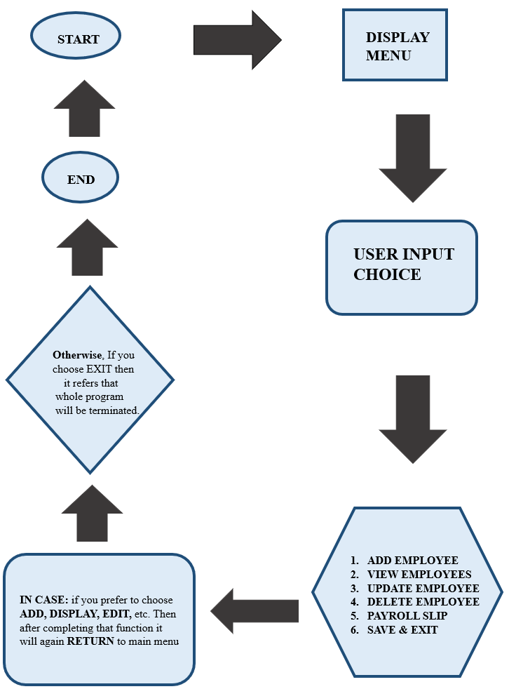

DESIGN APPROACH OF EMPLOYEE PAYROLL SYSTEM

The design approach of the Employee Payroll System focuses on creating a simple, user-friendly and accurate system for managing employee salary records. The system is designed in a modular manner so that each function performs a specific task. This makes the software easy to understand, develop and maintain.

First, the system is divided into different modules such as employee information module, salary calculation module, and payslip generation module.

The employee information module is responsible for storing employee details like employee ID, name, department, designation and basic salary. All records are stored in a database so that they can be accessed and updated easily.

The salary calculation module is the main part of the system. It calculates gross salary by adding allowances such as HRA and bonus to the basic salary. After that, deductions like tax and provident fund are subtracted to calculate the net salary. The formulas are applied automatically to reduce human effort and calculation errors.

Finally, the payslip generation module creates a report showing salary details including allowances, deductions and net salary. The report can be saved or printed for record keeping.

TESTING

System testing is carried out to check whether the Employee Payroll System works correctly and meets all the project requirements. The purpose of testing is to identify errors, verify calculations, and ensure smooth functioning of all modules.

Testing Approach
- Manual testing is used for the system.
- Each module is tested individually.
- The complete system is tested after integrating all modules.
- Both valid and invalid inputs are tested.

Modules Tested
- Admin Login
- Forgot Password
- Add Employee
- View Employee
- Update Employee
- Delete Employee
- Generate Payroll
- Save and Load File

Test Case Summary

Module | Input | Expected Result | Actual Result | Status
Valid Login | Correct credentials | Menu displayed | Menu opened | Pass
Invalid Login | Wrong password | Access denied | Error message | Pass
Add Employee | Valid details | Record saved | Stored successfully | Pass
Update Employee | Change salary | Data updated | Updated | Pass
Delete Employee | Employee ID | Record removed | Deleted | Pass
Payroll Calculation | Basic salary entered | Net salary calculated | Calculated | Pass
Generate Payslip | Select employee | Payslip displayed | Displayed | Pass
Save Data | Exit program | Data saved to file | Saved | Pass
Load Data | Restart program | Records loaded | Loaded | Pass

Testing Result
- All modules worked correctly
- Salary calculations were accurate
- System performed as expected

OUTPUT

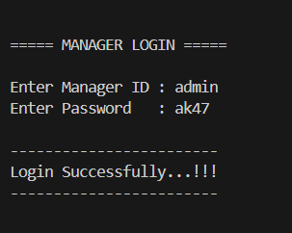

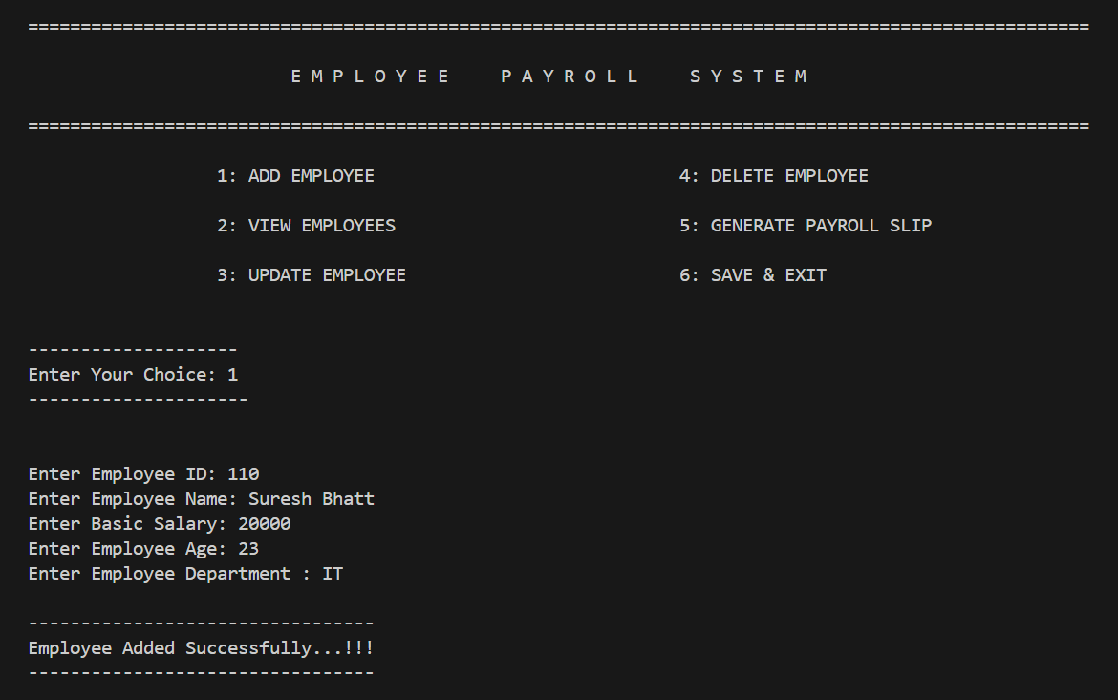

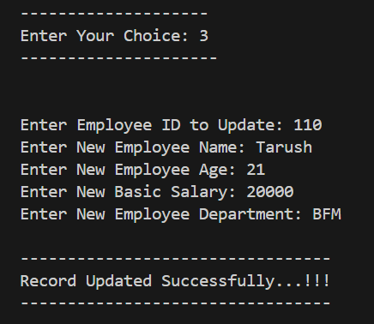

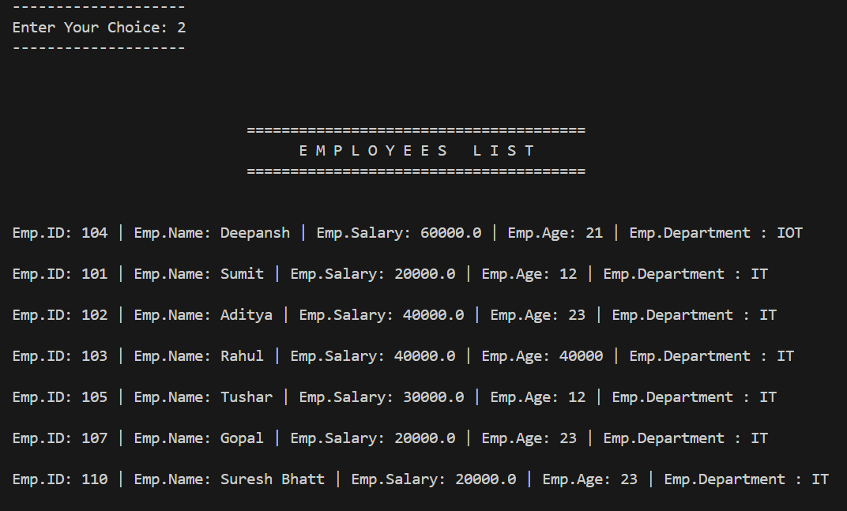

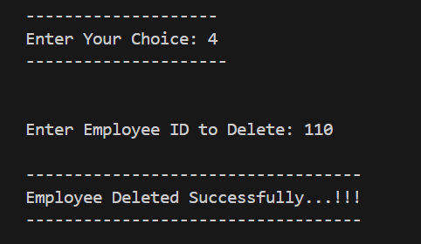

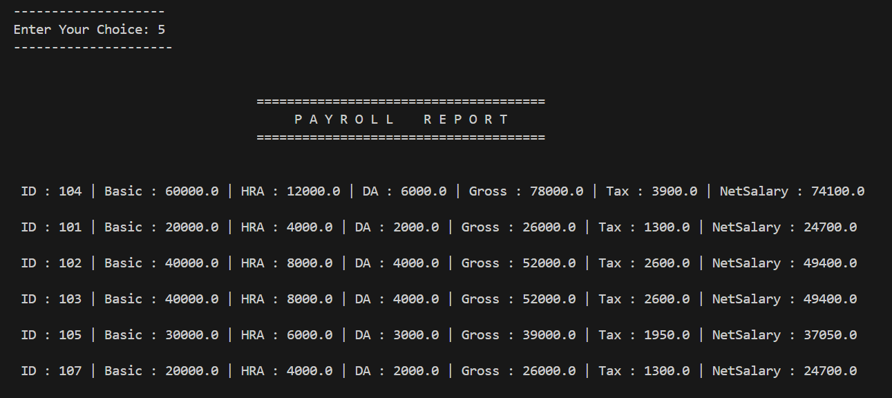

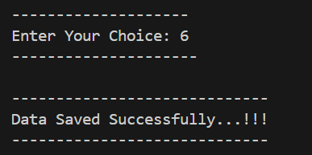

QUALITY ASSURANCE

Quality Assurance (QA) is an important process that ensures the Employee Payroll System meets the required standards of accuracy, reliability, and performance. The main objective of quality assurance in this project is to deliver a stable and error-free system that performs payroll operations efficiently.

Quality Assurance Practices Followed
- Coding Standards: Proper coding conventions and meaningful variable names are used to improve readability and ease of maintenance.
- Modular Design: The program is divided into different modules such as add, update, delete, and payroll generation to simplify testing and debugging.
- Input Validation: Employee ID duplication checks and proper input handling are implemented to prevent invalid data entry.
- Accurate Calculations: Salary components like HRA, DA, tax, gross salary, and net salary are verified to ensure correct calculations.
- File Handling Verification: Saving and loading employee data from the file is tested to ensure data persistence and avoid data loss.
- Manual Testing: Each module is manually tested to identify logical errors and ensure smooth system operation.

Outcome of Quality Assurance
- Improved system reliability and accuracy
- Reduced errors and improved performance
- User-friendly and maintainable payroll system
Overall, quality assurance activities ensured that the Employee Payroll System is dependable, efficient, and suitable for academic and practical use.

SOFTWARE MAINTENANCE

Software maintenance refers to the process of updating, modifying, and improving a software application after it has been developed and deployed. For the Employee Payroll System, maintenance ensures that the system continues to perform efficiently, remains error-free, and meets changing user requirements.

Types of Maintenance
- Corrective: Fixes errors or bugs in the system.
- Adaptive: Updates the system for new operating systems or compilers.
- Perfective: Improves performance or adds new features.
- Preventive: Prevents potential errors and ensures smooth operation.

Importance
- Ensures accurate payroll calculations
- Keeps the system compatible with updated software
- Improves user experience
- Extends the life of the software

FUTURE SCOPE

The Employee Payroll System has a strong future scope because most organizations are moving from manual record-keeping to computerized and automated systems. In future, this system can become more advanced, faster, and secure by using modern technologies.

In coming years, the payroll system can be developed as a cloud-based application. This will allow companies to access data anytime and from anywhere. Employees will also be able to download their salary slips and check payment history online.

The system may also be integrated with biometric attendance machines, so employee working hours, leaves, and overtime will be recorded automatically. This will make salary calculation more accurate and prevent manipulation. Security features such as password protection and data encryption can be added to keep employee information safe.

Future Improvements (Points)
- Integration with biometric attendance system
- Cloud storage for online access and backup
- Mobile app support for employees
- Automatic tax and salary calculation
- Direct bank transfer and online payment
- Strong security and data protection
- Integration with accounting software

Overall, the future of the Employee Payroll System is very promising as it will make payroll management easier, faster, and more reliable for organizations while also providing better services to employees.

CONCLUSION

The Employee Payroll System project successfully demonstrates a simple and effective way to manage employee records and automate payroll calculations. The system reduces manual effort, minimizes errors in salary computation, and organizes employee information in a structured manner.

By using fundamental C programming concepts like arrays, functions, loops, and file handling, this project provides practical learning experience for first-semester BCA students. It also highlights the importance of modular programming and data management.

The system is reliable, easy to use, and can be further enhanced in the future with features like database integration, GUI, multi-user access, and advanced reporting. Overall, the project serves both academic and practical purposes by providing a functional payroll management solution suitable for small organizations.

BIBLIOGRAPHY

Books
- Let Us C by Yash Kanetkar

Websites
- GeeksforGeeks, C Programming Tutorials, https://www.geeksforgeeks.org/c-programming-language/
- TutorialsPoint, C Programming Guide, https://www.tutorialspoint.com/cprogramming/index.htm
Tools & Software
- Visual Studio Code – Integrated Development Environment (IDE) used for programming.

